# Methods

Data was taken from the SEEDLingS corpus (Bergelson, 2016), a longitudinal set of data incorporating at-home recordings, parental reports and experimental studies from the ages of 0;6 to 1;6. This study draws on the parental report data, and annotations of hour-long home video recordings, taken on a monthly basis during data collection.

**Participants** Forty-four families in New York State completed the year-long study. Infants (21 females) were from largely middle-class households; 33 mothers had attained a B.A. or higher. All had normal birthweight with no reported speech or hearing problems. Forty-two infants were Caucasian; two were from multi-racial backgrounds.  
  
**Parental report data** used for the present analyses included a vocabulary checklist (the Macarthur-Bates Communicative Development Inventory, hereafter CDI; Fenson et al, 1994), administered monthly from 0;6 to 1;6, along with a demographics questionnaire. Because the majority of infants did not produce their first word until 0;11 (M=10.8, SD=1.6), we use CDI data from 0;10 onwards in our analysis. CDI production data for each month is taken as a measure of the infants’ lexical development over the course of the analysis period.   
  
**Home video data** Each month from 0;6 to 1;5, infants were recorded for one hour in their home. Infants wore a hat with two small video cameras attached, one pointed slightly up, and one pointed slightly down; this allowed us to record the scene from the infants’ perspective. In the event that infants refused to wear the hats, caregivers wore the same kind of camera on a headband. Additionally, a camcorder was set up in the home. Object words (i.e. concrete nouns) deemed to be directed to or attended by the child were annotated by trained coders. Here we examine annotations for speaker, i.e. who produced the word, and object presence, i.e. whether the word’s referent was present and attended to by the infant.

## Analysis

We analyzed number of siblings based on parental report in the demographics questionnaires completed at 0;6. Sibling number ranged from zero to four sibling per infant, who were on average 5.5 years older than the infants (Mdn: 3;06, SD: 4;06, R: 1-18 years).[1] All siblings lived in the household with the infant, and all were older than or of the same age as the infant in question.[2]

## Input measures

Three input measures were considered in our analysis, pertaining to aspects of the input that are established as being important in early language learning: overall *parental input* (how much speech does an infant hear?), *early-acquired words* (how much of that speech features early-learned nouns?), and *object presence* (how much of that speech is referentially transparent?).

**Parental Input** reflects how many object words infants heard in the recordings from their mother and father (where relevant, we also calculated sibling input). Other speakers’ input was relatively rare during video recordings, and is excluded here.

**Early-acquired words** reflects how many of the object words in the input (or their lemmas in the case of plurals and diminutives) appeared on the “Words & Gestures” CDI. This CDI form (Fenson et al., 1994) offers an inventory of words typically acquired by infants from the United States between the ages of 8 and 18 months (Fenson et al., 2007). Acquisition norms were established from a sample of over 1,700 infants from diverse backgrounds (~50% firstborn, 73% White, 44% of mothers with a college diploma), and so the CDI is taken as a standardized proxy of words typically acquired by infants in early development. Words found on the CDI are, by definition, more learnable in early acquisition, though the reasons underlying their learnability likely differ. Thus, we assume that CDI words like *foot* and *banana* are lexically simpler (or more readily learned) than concrete nouns like *jet ski* or *wheel*, acknowledging that many factors (e.g. frequency, concreteness, phonology) contribute to this.   
  
**Object Presence** was coded for each object word in the home recordings based on whether or not the annotator determined the object in question as present and attended to by the child. This is a metric of referential transparency, which has been suggested to aid in learning (Bergelson & Swingley, 2013).

In the following analyses, we consider infants’ productive vocabulary alongside quantity, lexical simplicity, and object presence in the input, as a function of sibling number. Since the raw data are highly skewed, log-transformed data[3] and/or proportions are used for statistical analysis. All figures will display non-transformed data.

# Results

Vocabulary development was highly variable across the 44 infants. By 18 months, two infants produced no words, while mean productive vocabulary was 60.3 words (SD=78.3, Mdn=30.5). One infant was excluded as an outlier, leaving 43 infants (20 females) in the present analysis.[4] Infants had one sibling on average (M=.86, Mdn = 1, SD = 1.09). See Table 1.

Table 1: Sibling Number across Male and Female Infants

|  |  |  |  |
| --- | --- | --- | --- |
| **Siblings** | **M** | **F** | **Total** |
| **0** | 12 | 9 | 21 |
| **1** | 6 | 7 | 13 |
| **2** | 3 | 2 | 5 |
| **3** | 0 | 2 | 2 |
| **4** | 2 | 0 | 2 |
| **Total** | 23 | 20 | 43 |

**Model structure for fixed and random effects**All reported models use linear mixed-effects regression, with p-values generated by likelihood ratio tests resulting from nested model comparison (using the lmer library in R; R Core Team 2016). All models include infant as a random effect. All post-hoc tests are two-sample, two-tailed Wilcoxon Tests, given the underlyingly non-parametric nature of our variables. Before considering sibling status, we first modeled infants’ productive vocabulary and input as a function of age, sex, and mother’s education. We include age as a fixed effect in all models. Model comparison supported including a 3-way interaction (age by sex by maternal education) in our production model, but not in the input models.[5] Likely due to our relatively narrow range of socioeconomic status, there was no correlation between mother’s education and infants’ productive vocabulary at 18 months (Spearman’s ρ =.12, p=.45). There was also no correlation between mother’s education and number of siblings (ρ =-.038, p=.81). There was a significant positive correlation between mother’s age and number of siblings (ρ =.24, p<.000): older mothers tended to have more children. However, no correlation was found between mother’s age and productive vocabulary at 18 months (ρ =-.04, p=.82).

## Effect of siblings on infants’ productive vocabulary

We next modeled the effect of siblings on productive vocabulary. Whether sibling was modeled as a binary variable (0 or >0), aggregated grouped variable (None, One, 2+), or the actual discrete sibling number (0-4), models with sibling accounted for more variance in productive vocabulary than models without it (binary: χ2(1)=5.5, p=.02, t=-2.4; aggregated: χ2(1)=9.6, p=.008, t=-2.17; discrete number: χ2(1)=9.83, p=.002, t=-3.32.) In short, having more siblings was associated with a smaller productive vocabulary, across 10-18 months. See Figure 1.

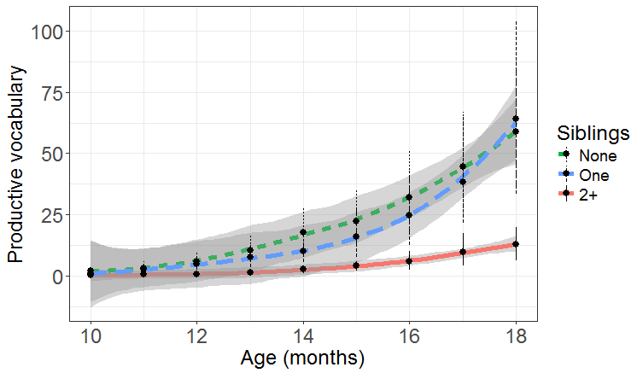  
Figure 1: Productive vocabulary acquisition over time. Colors denote sibling group; line with grey confidence band reflects local estimator (loess) fit over individual infants’ vocabulary at each month. Dots indicate mean with bootstrapped 95% CIs computed over each months’ data.

Productive vocabulary acquisition over time. Colors denote sibling group; line with grey confidence band reflects local estimator (loess) fit over individual infants’ vocabulary at each month. Dots indicate mean with bootstrapped 95% CIs computed over each months’ data.

Consistent with previous findings (Hoff, 2006; Pine, 1995), infants with siblings acquired around 61% fewer words over the course of the analysis than those without, and for each additional sibling, infants acquired 38% fewer words. We present the aggregated group findings for subsequent analyses and figures, given the unbalanced group sizes across sibling number, and highlight any meaningful differences in model results between sibling number (0-4) and sibling group (None, One, 2+).

We considered our findings across the range of ages tested. Wilcoxon rank sum tests comparing groups at each age showed no significant difference at any point between total words reported for None vs. One infants (all ps>.5). While the difference between One and 2+ infants was not consistently significant, we observe an increasingly large difference between these two groups, with significant effects first noted at 1;0 (Est.Diff.=-3, p=.04), then again at 1;2 (Est.Diff.=-5.3, p=.05), and then consistently between 1;4 and 1;6 (all Est.Diffs.>-11, all ps≤.01).

## Effect of siblings on infants’ linguistic input

Turning now to effects of siblings on infants’ linguistic input, we examined our three input quality measures in the home video recordings.

**Parental Input** Mothers provided the largest proportion of the infants’ overall input across the sample (M=.72, Mdn=.86, SD=.33), with fathers accounting for an average of 14% (Mdn=0, SD=.28). Infants with siblings received around 9% of their input from their brothers and sisters (Mdn=.04, SD=.12). We tested overall quantity of input (aggregated across mothers, fathers, and siblings) in our model, and a significant effect was found (χ2(2)=9.61, p=.008). Post-hoc comparisons showed a significant difference between infants with one sibling versus those with two or more siblings (Est.Diff.=-74, p<.000), while infants with no siblings heard almost the same amount of input as those with one sibling (Est.Diff.=-2.32, p=.98). These effects remained when input from siblings was removed from the data (Overall model: χ2(2)=11.16, p=.003; One vs. 2+: Est.Diff.=-71, p<.000); infants with two or more siblings receive less caregiver input, as well as less household input overall.

**Lexical Simplicity** We expected infants with more siblings to hear fewer lexically simple words (i.e. fewer words that occur on the CDI). We consider this with regard to both amount and proportion of total household input. On average, 61% of the object words heard in the infants’ inputs were lexically simple (Mdn=.62, SD=.13). Infants with no siblings heard a higher quantity of such words overall (see Figure 2), but this was not true for proportion of lexically simply words. Indeed, sibling group accounted for a significant amount of variance, above and beyond the effect of age, on lexical simplicity, but not proportion (quantity: χ2(2)=9.52, p=.009; proportion: χ2(2)=.84, p=.66).

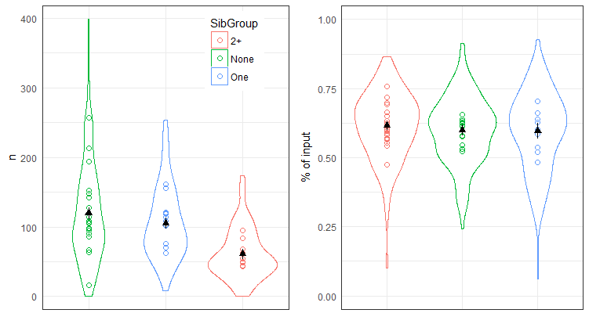

Figure 2: Number of lexically simple words in the input across sibling groups. Error bars indicate mean learnable words heard across groups, with bootstrapped 95% CIs computed over all months’ data. Dots indicate mean number of learnable words per infant, collapsing across age.

Post-hoc comparisons averaging over age found that infants with one sibling heard significantly more lexically simple words than those with two or more siblings (Est.Diff.=-40, p<.001), but there was no difference between the lexical simplicity of the inputs of infants with no siblings and those with one sibling (Est.Diff=10, p=.11).

**Object Presence** On average, 60% of utterances were produced in the presence of the relevant object (Mdn=.62, SD=.17). We hypothesized that infants with more siblings would hear fewer words in referentially transparent conditions (i.e. experience lower object presence) than those with fewer siblings.

Indeed, modeling the quantity of object present tokens that infants heard, we find a significant effect for sibling group on object presence (χ2(2)=14.69, p<.000). In contrast to lexical simplicity, here we find this difference for the *proportion* of object presence as well: the proportion of utterances accompanied by object presence was significantly higher for infants with fewer siblings (χ2(2)=32.8, p<.000, see Figure 3). Infants with no siblings experienced 18% more object presence in their input than those with two or more siblings (t=6.89).

Post-hoc comparisons revealed significant between-group differences: infants with no siblings experienced significantly more object presence than those with one sibling across overall input (Est. Diff.=22.99, p=.001) and proportion of object presence (Est.Diff.=.1, p<.000). Likewise, infants with one sibling experienced significantly more object presence across both measures than those with two or more siblings (quantity: Est.Diff.=-.46, p=.001; proportion: Est.Diff.=-.08, p<.001).

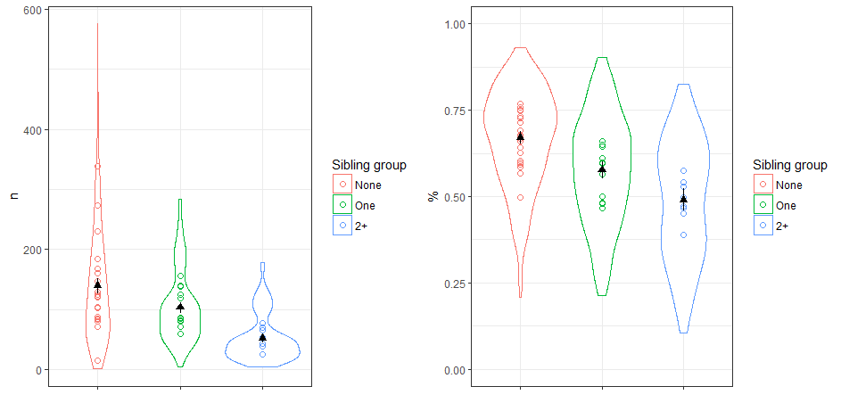

Figure 3: Proportion of object presence in the input across sibling groups. Error bars indicate mean proportion of object presence (CIs as in Fig. 2). Dots indicate mean proportion of object presence per infant, collapsing across age.

**Sibling Age** Sibling ages varied widely across the data, from zero to 6193 days older than the infant (M=1876 days, SD=1462.74). Input is likely to differ as a function of sibling age; older siblings, for example, likely use more adult-like language and receive more adult-directed input from caregivers. On the other hand, siblings who are still toddlers will produce and receive input that is more similar to that of the infant. For the purposes of this analysis, siblings who are more than three years older than the infant are described as ‘Older’ siblings, while those who are under three years older are termed ‘Younger’ siblings (though note that no sibling is younger than the infant in chronological age). These age differences were selected based on the assumption that input and output would differ for siblings in each of these groups; caregivers would address Younger children differently from Older children, and speech of Younger children would be less adult-like than that of Older children (see Hoff-Ginsberg & Krueger, 1991 - probably more REFS needed here). With this in mind, the infants’ experience would differ according to the age category of their siblings. Older siblings were on average 2585 days older than the infant (Mdn=2020, SD=1405.6), while Younger siblings were 660.9 days older (Mdn=738.5, SD=284.55).

First, we ran a correlation of mean sibling age (mean age in days of each sibling/number of siblings) and total words acquired by 18 months. A significant negative correlation was found (Spearman’s ρ =-.56 p=.02); infants with siblings of a higher mean age had acquired fewer words by 1;6. One infant had two teenage siblings and was an outlier in our data (mean age more than three SDs above the mean), but when removed from the analysis the correlation remained (ρ =-.59 p=.02). To explore this result further, we ran two linear mixed-effects models with number of Older siblings and number of Younger siblings as factors, respectively. As in previous models, age was included as a fixed effect and infant as a random effect, with total words acquired per month (log-transformed) as our dependent variable. Number of Younger siblings had no effect on the data (χ2(1)=1.21, p=.27), but there was a significant effect for number of Older siblings (χ2(1)=7.86, p=.005). For each additional Older sibling, infants acquired around 35% fewer words. However, this result is confounded with sibling group: infants with older siblings were also those with more than two siblings. Fourteen infants in our data had Older siblings, of which 10 were in the 2+ group, including all four infants with three or four siblings. In contrast, all infants with only Younger siblings were in the One Group (six infants in the 2+ group had one younger siblings, but they also had at least one older sibling). It is therefore not possible to determine precisely whether these infants’ language development was slower due to having more siblings, or due to having older siblings. It is possible that both factors play a role in our results.

1. For two infants, the age difference of their siblings (n=6) was estimated in years due to incomplete demographic information.
2. Two infants in the dataset were dizygotic twins, our pattern of results holds with or without these infants.
3. 1 was added to the raw infant production data before log-transformation to account for months with zero words.
4. This infants’ vocabulary was far above average; by 18 months her lexicon was more than 3 SDs above the mean.
5. Females and infants with more highly educated mothers (which by chance co-occurred leading to the 3-way interaction) had a higher productive vocabulary than males or children of lower-educated mothers; this effect grew with age. Other fixed effect structures across the models did not change overall results.